**Database Notes Dated 29-10-2022**

**SQL:-** SQL stands for structured query language. It is used to perform database operations. Based on  database operations sql is divided in four parts:-

1. DDL (Data Definition Language)

2. DML (Data Manipulation Language)

3. DCL (Data Control Language)

4. TCL (Transaction Control Language)

**Commands of DDL:-**

i.) create:- create command is used to create a new database object.

create table table_name

create view view_name

create user user_name

ii.) alter:- alter command is used to modify structure of database object.

iii.) drop:- drop command is used to delete database object.

iv.) truncate:- truncate command is used to delete all data from database object.  v.) backup:- backup command is used to take backup of database.

vi.) restore:- restore command is used to reconstruct database from its backup.  **Commands of DML:-**

i.) insert:- The insert command is used to insert record into database object (table,view).  ii.) delete:- The delete command is used to delete record from database object.  iii.) update:- The update command is used to modify record in database object.  iv.) select:- The select command is used to select records from database object.

**Commands of DCL:-**

i.) grant:- grant command is used to give rights to database user.

ii.) revoke:- revoke command is used to take off rights from database user. It is just opposit to grant  command.

iii.) rename:- rename command is used to change name of database object.

**Commands of TCL:-**

i.) commit:-commit command is used to save transaction.

ii.) rollback:- rollback command is work like undo.

Use of create command to create a new user:-

Syntax:-

create user <username> identified by <password>;

E.g.

create user app2022 identified by test;

Use of grant command to give rights to user:-

Syntax:-

grant <rights> to <username>;

E.g.

grant dba to app2022;

**Database Notes Dated 30-10-2022**

Use of create command to create a new table:-

Table:- Table is a collection of rows and columns. Rows are called tuples and columns  are called attributes.

Syntax to create table:-

create table <tablename>

(

<column1> <datatype>,

<column2> <datatype>,

<column3> <datatype>

);

Table Name:- employee

empid int PRIMARY KEY

empname varchar2(30)

department varchar2(20)

salary int

Primary Key:- Primary key is a field in a table, which is used to identify each record  uniquely. It is atomic and not null.

create table employee

(

empid int primary key,

empname varchar2(30),

department varchar2(20),

salary int

);

Use of insert command to insert record into table:-  Syntax:-

insert into <tablename> values(<value1>,<value2>,<value3>);  E.g.

insert into employee values(1001,'Brijesh','Development',45000);  Use of select command to select records from table:-  select * from employee;

insert into employee values(1002,'Ajay','Management',80000);  insert into employee values(1003,'Nisha','HR',40000);

insert into employee values(1004,'Shikha','Development',50000);  _________________________________________

Use of insert command to insert data in specific columns of table:-  Syntax:-

insert into <tablename> (<column1>,<column2>) values(<value1>,<value2>);  E.g.

insert into employee(empid,empname,department)

values(1005,'Shubham','Development');

_________________________________________

Use of select command:-

1. Use of select command to select all columns of table.

select * from <tablename>;

select * from employee;

2. Use of select command to select specific columns.

select <column1>,<column2> from <tablename>;

select empid, empname, salary from employee;

Use of where clause:- where clause is used to specify condition in sql statement.

select * from <tablename> where <condition>;

E.g.

select * from employee where empid=1001;

________________________________________

Operators in SQL:-

= equality

> greator than

< less than

>= greator than or equal to

<= less than or equal to

<> not equal

in compare value in given values

between check whether given value is available in given range or not  like This operator is used for pattern matching

_________________________________________

Use of delete command to delete record from table:-

Syntax:-

delete from <tablename> where <condition>;

delete from employee where empid=1001;

_________________________________________

Use of update command to modify record of table:-

Syntax:-

update <tablename> set <column1>=<value1>, <column2>=<value2> where  <condition>;

E.g.

update employee set salary=40000 where empid=1005;

_________________________________________

Use of truncate command:-

Syntax:-

truncate table <tablename>;

truncate table employee;

_________________________________________

Use of drop command:-

Syntax:-

drop table <tablename>;

drop table employee;

For deleting Oracle/SQL –

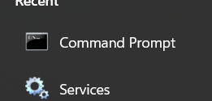

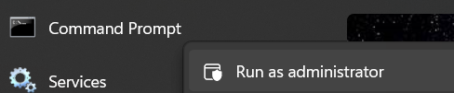

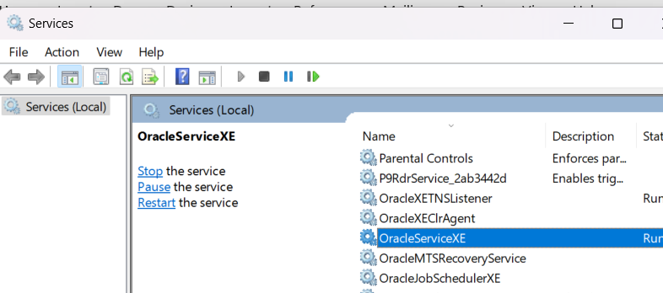

🡪Command for delete…

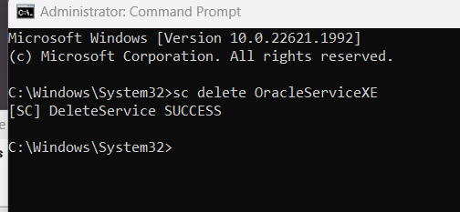

After refresh OracleServiceXE –> oracle is deleted.

* For running SQL
* AT first time
* 